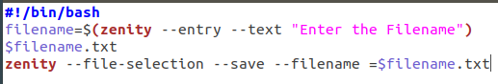
LAB 12
TASK01
CODE

EXECUTION
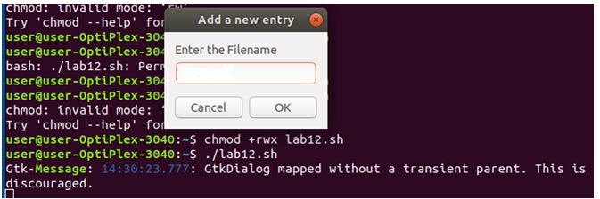

TASK02
CODE
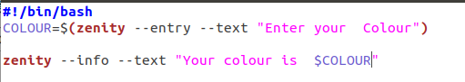

Execution

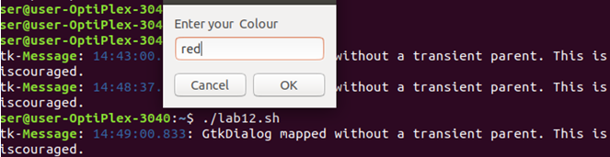

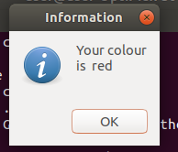
OUTPUT

TASK03

CODE

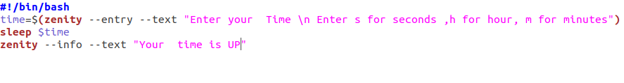

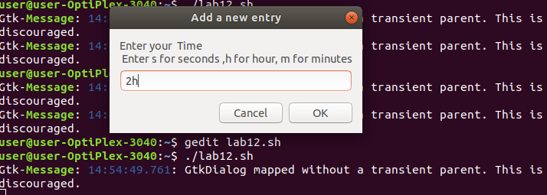
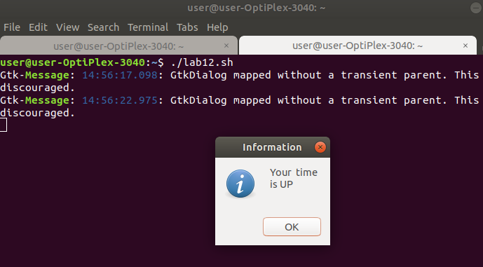
Execution

OUTPUT

